There have been a small percentage of customers that have complained that since the doorbell has been installed that their doorbell chime is humming, buzzing, or rattling or their plungers in their chime are constantly moving. We believe this is happening because some of the current is passing through the chime relay, acting as if your chime has received a weak push from the doorbell.

If this is bothersome, please see the following instructions on how to solve:

To circumvent this, the resistor which is included in your doorbell package needs to be connected to your chime in which one end is connected to the doorbell connection and the other end is connected to the transformer connection.

**Disconnect Power from your entire Doorbell system by turning off your breaker switch before attempting the following.**

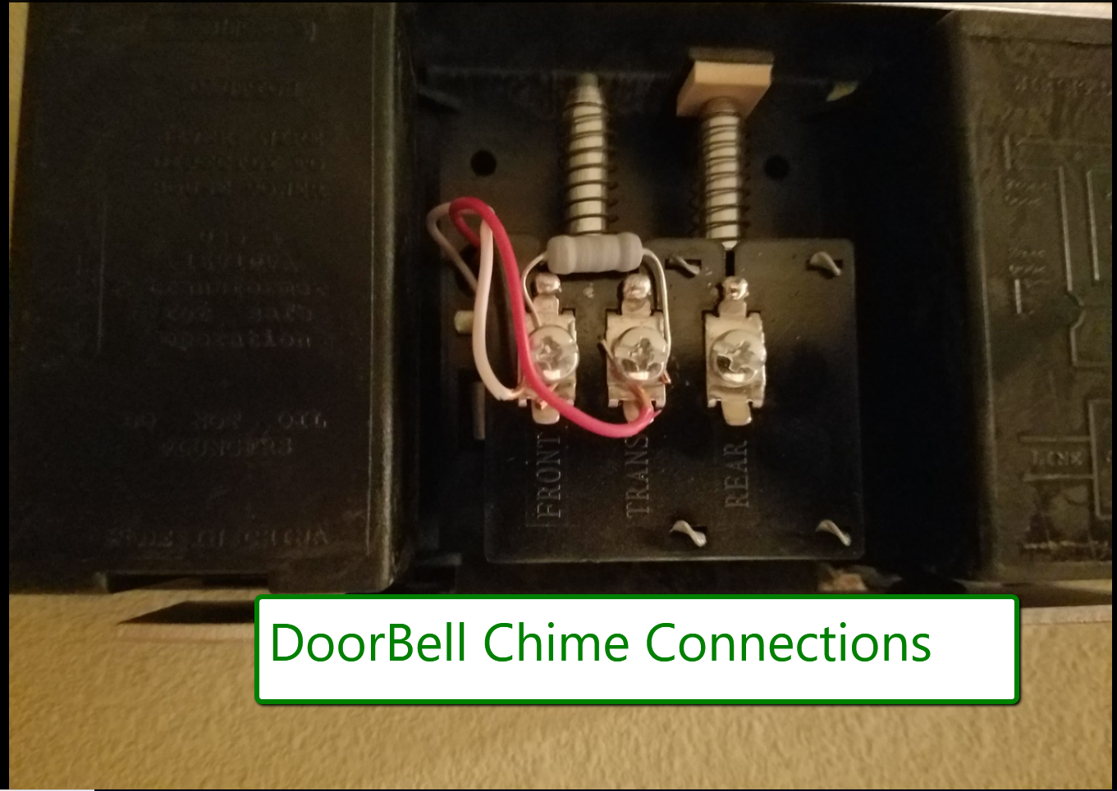

Please note that the only downside to this setup is that your chime may now only do a "Ding" instead of a "Ding Dong"